**WORKSHOP 1B: Mapping Sufferers & Caregivers Biblically**

**____________________________________________________________________________________**

1. **Suffering in the Bible**
2. **Suffer because of broken Creation**

(Gen.2:1-3, 3:1-24; Rom. 8:19-22)

1. **Suffer because of others’ sin**

(Gen. 4:8, 6:9-14; Rom.1:18-32, 5:12)

1. **Suffer because of your own sin**

(Rom.1:18-32)

1. **Suffer the persecution for your faith**

(2Tim.3:12, Heb.10:32-34, 11:35-40)

1. **Suffering produces endurance**

(Rom.5:3-5)

1. **Suffering of Jesus**

(Hebrews 4:15, Isaiah 53:3)

1. **Suffering under God’s sovereignty**

(Job 13:3, 13-15, 38:2-4, 42:2-6, Hab.3:16-19, Acts 2:23)

1. **No more suffering**

(Revelation 21:1-4)

1. **Mapping the Sufferer Biblically**

1. **Embodied Soul1**

spirit

body

(Psalm 63:1)

1. **Sinner, Saint & Sufferer2**

(James 1:19-21, 1:2-3, 4:4-10)

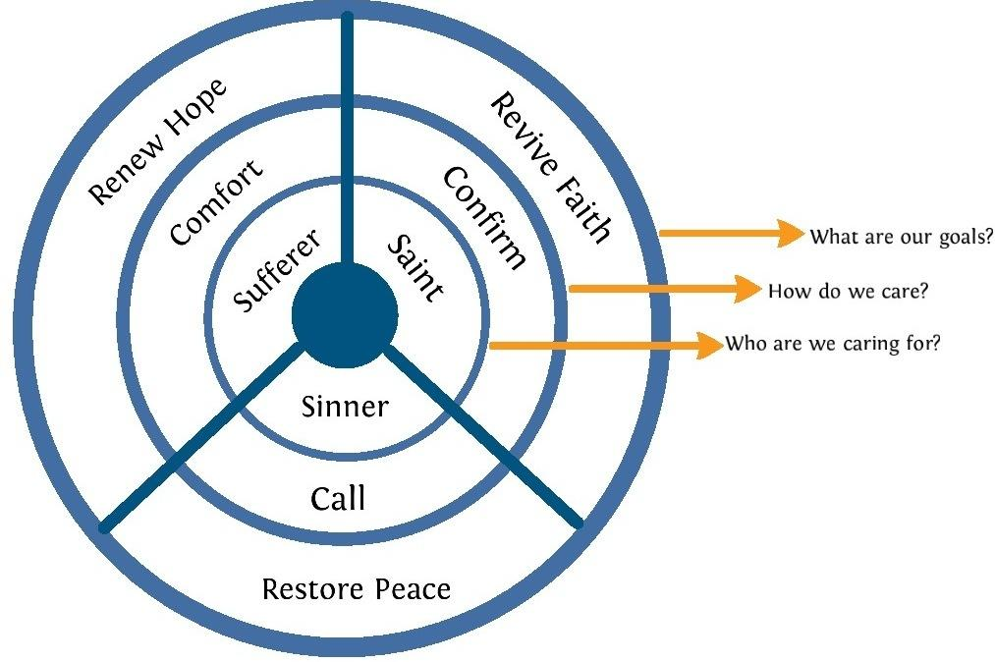

1. **‘Heat’ in Lane & Tripp’s 3 Trees3**

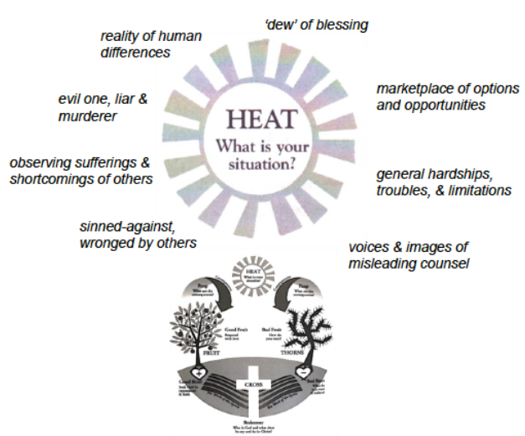 (Psalm 88, James 1:1-15)

1. **Sufferer in Christ’s Body**

(James 5:13-20)

1. **Mapping the Caregiver Biblically**
2. **Caregiver’s Self-Awareness**
3. I.R. = F (me, others)
4. Sinner, Saint, Sufferer
5. James 4:1-4, Luke 6:43-45
6. Letters of Jack Miller (p.26-29 & 267-270)
7. Bowen Family System Theory (p.280-287)
8. **Caregiver’s Posture**
9. Fundamental Posture of Humility & Love (Eph.4:1-2)
10. Posture of Collaborative Prayerfulness (Jas.1:2-8)
11. Posture of 'Serpents & Doves' (Matthew 10:16)
12. Relating as 'fellow Sinners, Saints, Sufferers'
13. Relating to Those Suffering (2 Corinthians 1:3-4)
14. Relating to Those with Difficult Personalities (Mat.7:3-5)
15. **Caregiving in Christ’s Body**
16. James 5:13-20
17. 1 Corinthians 1:12-27