**WORKSHOP 1A: Mapping Pastoral Care**

**____________________________________________________________________________________**

1. **‘Pastoral Care’ in the Bible**
2. **Pastoring = Shepherding**

1. **God as Shepherd of Israel**

(Psalm 77:20 Ezekiel 34:11-16, Psalm 23:1-6)

1. **Israel’s King as Shepherd**

(2Samuel 5:2)

1. **Israel’s Leaders as failed Shepherds**

(Ezekiel 34:1-10, Jeremiah 23:1)

1. **The Messiah as Shepherd**

(Ezekiel 34:23-24, Jeremiah 3:15 )

1. **Jesus as Good Shepherd**

(John 10:14-16, Luke 15:3-7)

1. **Elders as Shepherd of God’s Flock**

(Acts 20:28-29, 1Peter 5:1-11)

|  |
| --- |
| **Shepherding/Pastoring in the Bible**   1. **God** is the ultimate Shepherd of His people who leads His people into eternity with Him. 2. **Jesus Christ** is God’s chosen Chief Shepherd who laid his life as the sacrificial Lamb to rescue God’s people, and through whom God now rules over and cares for His people. 3. **Elders** are God’s gifted shepherds (pastors) through whom Jesus rules and cares for God’s people through His Word by His Spirit. 4. **Shepherding** concerns the sacrificial, authoritative and compassionate leading of God’s people under God, by His Word, into Eternity with God – which involves protecting, providing and guiding the people, point people to Jesus. |

1. **‘Pastoral Care’ in Pastoral Ministry**
2. **Pastoral Ministry / Shepherding Work in God’s Plan & Purposes**

Pentecost

2nd

Coming

1st

Coming

Ascension

Rule of Christ

Word & Spirit

Fall

Death & Resurrection

Promises

Creation

New

Creation

**Shepherding**

**Work**

**Pastoral**

**Ministry**

1. **‘Pastoral Care’ in Pastoral Ministry**

Pastor/Elder

*‘Pastoral Care’ provides social, relational, physical, emotional needs e.g. chauffeuring the sick, hospital visits, listening to the lonely, walking with the depressed, fundraising for the poor, being present for the bereaved.*

1. **‘Pastoral Care’: A Working Definition**

|  |
| --- |
| .  ‘Pastoral Care’ is part of Shepherding which is the sacrificial, authoritative and compassionate leading of God’s people under God, by His Word, into Eternity with God. It involves providing social, relational, physical, emotional needs to create a context where sufferers are cared for wholistically with the goal to shepherd them into eternity.  . |

1. **‘Pastoral Care’ Today & In Church History**

|  |  |
| --- | --- |
| 2023 | ‘Pastoral Care’ in Gongshang Primary School & NTU |

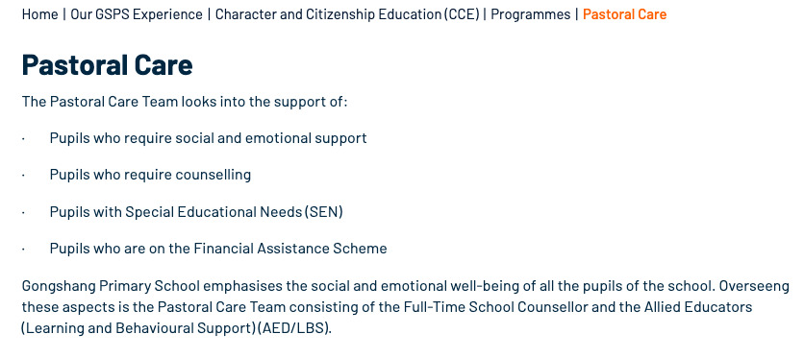

**How did we get here?**

|  |  |
| --- | --- |
| 358AD | Gregory of Nazianzus: ‘Physician of Souls’ |
| 590AD | Gregory the Great: ‘Consideratio’ & Spiritual Perspective |
| 1541 | Martin Bucer: ‘On the True Pastoral Care’ |
| 1700s | Revivalism |
| 1859 | Darwin’s *Origin of Species* |
| Late 1800s | Psychology Evolution with Wundt & Freud |
| WW1&2 | Wartime clergy |
| Mid 1900s | Carl Rogers’ Person-centred Approach  *Carl’s theory involves a self-concept, which subsumes three components: self-worth, self-image and ideal self. Rogers developed an approach of client-centred therapy to help people self-actualize, or reach their full and unique potential.* |
| 1930s | Boisen & Clinical Pastoral Education. |
| 1980s | Pastoral Care in schools concerns the promotion of health and wellbeing, resilience, academic care and social capital. |
| 1987 | Total excellence in schools |
| 2023 | ‘Pastoral Care’ in schools, hospitals, churches.  **'Pastoral Care' Today**  It is clear that 'pastoral care' today is removed from its biblical roots which involves the shepherding of God's people into eternal bliss: 'Pastoral Care and Guidance seek to help students realise their potential and work towards actualizing it…It must be noted that the term does not have any spiritual connotation... not only intellectual but social and emotional' (7th APECA, 1987). |
|  |  |

1. **Pastoral Care in a Local Church**

**Life Issues**

|  |  |  |  |  |
| --- | --- | --- | --- | --- |
| Marital  Abuse | Marital  Conflict | Premarital  Sex | Miscarriage | Infertility |
| Dating  Unbeliever | Porn  Addiction | Alcoholic | Gambling Addiction | Gaming  Addiction |
| Same-sex  Attraction | Eating  Disorder | Discontentment & Jealousy | Workaholic | Anger |
| Adultery | Dementia | Down  Syndrome | Work  Stress | Suicidal  Ideation |
| Chronic  Pain | Terminal  Illness | First  Child | Loneliness | Caregiver  Fatigue |
| Unemployment | Postnatal  Depression | Insomnia | Conflict | Financial  Stress |

**Spectrum of Issues**

**Crisis**

**Severe**

**Moderate**

**Easy**

**Mild**

**Need Pastor!**

**Lay Person**

**Typical Local Church Ministries**

**Exercise**

Pick a few life issues. For each: 1) Reflect on how you perceive the issue, where on the spectrum would you typically place the issue? 2) Where in the ministry of the local church has pastoral care on this issue been given, and the lay equipped to offer care?

1. **Case Scenarios**

Based on what you have learnt from the class about biblical pastoral ministry (and its subset pastoral care), what would pastoral care for this individuals involved in a given week?

1. **Grieving Grace**

Grace recently lost her mom to cancer. Soon after retirement, the seemingly healthy and active Christian lady was unexpectedly diagnosed with stage four lung cancer. After few months of chemo treatment, she died last week – less than a year after diagnosis. She is survived her husband and her only child, Grace. While Grace finds comfort in mom being a believer, she is grieving by the sudden loss - she was very close to her mom.

1. **Depressed Danny**

Danny relocated recently from Auckland to Singapore for work. This is the first time is away from his family and church. For 6 months, he finds it hard adjusting to the new work culture, and struggles with making new friends in a big church. His diet and sleep routine hasn’t been great. He has started seeing a psychiatrist and a counsellor, was diagnosed with depression and put on anti-depressants. Though difficult, he can still function at work and move around.

1. **Hospitalised Horace**

Horace’s wife is pregnant and expecting to deliver any time soon. One Sunday afternoon after church, Horace ruptured his Archilles tendon in basketball game. Horace is admitted to prepare for surgery the next day. He has to stay a night for observation post-surgery and will be on crutches for at least the next 6-8 weeks.

1. **Marriage-Conflicted Maggie**

Maggie shared recently that her marriage to Colin hasn’t been in a good place for a while. At the beginning they still raised their resentment and issues to each other, even though there was hardly resolution. But now they have both ‘given up’ and not fight anymore. They busy themselves with work and hardly talk to each other, except for logistical arrangements around family affairs. There is no emotional connection, and she is considering divorce.

1. **Same-sex Attracted Stan**

Stan became a Christian in secondary school through a friend who eventually brought him to church where the Lord grew Stan in conviction. He is an encouraging member of a local church where he serves regularly. As Stan got exposed to Christians’ discussion LGBTQ, he slowly came to understand the homosexual feelings he experienced since young. One day, he shared with you he’s gay and that he feels ‘utterly, eerily, helplessly lonely and isolated’.

1. **Addicted Andy**

Andy shared privately with you that he has been struggling with porn addiction since high school, when he accessed internet porn regularly. There were porn-free periods, especially after he became a Christian in university. In fact, he remained porn-free many years into his marriage. However, last year when he experienced great work pressure, felt disconnected with his wife, frustrated with parenting – he turned to porn, and it has been unabating since.