TCC G360 Biblical Counselling Module

Week 3: Word Ministry

Week 3 Teaching Objectives
- To give apprentices a framework for the process of biblically counselling another person well.
- To give apprentices a framework for biblical counselling with the local church as a ministering community where every believer plays a part.

- Quick Recap of Week 2

- Your Reading Reflection

- What questions do you have from this chapter?
- Paraphrase the point of the chapter.
- How would this shape or change how I think about myself, others, and ministry? How would I do ministry differently?

- Chapter 2: The Facts of Life

- Chapter 3: Hearing the Music of the Gospel

- Chapter 4: How Healthy Is Your Preparation

- Chapter 5: What Questions Do You Ask

- Chapter 10: What is ‘Ministry of the Word?’

- Chapter 13: Pastoral Counselling

- Interpersonal Word Ministry
God’s Word reveals life in fallen word

Sovereign God
voices & images
general hardship, limitations
my & other’s sin
my & other’s suffering
human differences
blessings

Faith works through love

J
Faith grows.
Seeks God’s mercy & grace.
J
God’s Word reveals life
of faith & obedience
Listens
Trusts
Loves Obeys
Relies

!@#$%
God’s Word reveals nature of sin
& our heart.
Body-Spirit
J

God’s Word reveals Himself &
His plans in Jesus (my sanctn & glorn)

- Reframes life troubles with an eternal perspective

- Leads people to face themselves honestly (as God sees them)

- Promotes not human-human but human-Saviour interaction;
bringing the living Christ to people.

- Steps into life troubles ‘common to all’ with humility

- Works collaboratively with the person, seeking to understand the person’s unique situation & heart

- Aims for Christ-orientation & progress, not perfection

- Thinks globally and acts locally; one bit of Bible to one bit of life

- Tuning Fork of Biblical Counselling
- Local Church as the ministering community

- Formal Word ministries

public  preaching | PF  youth | workshops | CG | prayer  triplets | post-sermon | 121s | pastoral  counselling
1&2Ki. Gal. Guidance Gen. Col. difficult situatns
prob-centred

e.g. Phil.4:2 Euodia & Syntyche to agree
e.g.Phi.17 Philemon to receive O-nee

- Common Situation
“My CG member has a pastoral issue… XYZ. I don’t know how to help. It’s complex and messy. I’ve no experience. It’s beyond my pay grade. I’m not trained. I’ve no time. I tried, nothing happened.”

... irregular at CG
... always late for church
… suffering depression/suicidal
... eating disorder
... once CGL but now burn-out
... suffers a chronic illness
... engaging in pre-marital sex
... consistently stressed with work
... conflict w another CG member
... dating non-Christian
... bullied at work
... confessed to porn addiction
… angry, blows up at home/work
... prioritises work/socials over CG
... dejected by failed relationship
... in marital conflict w spouse
... struggling w infertility
... stressed by newborn

... struggling w singleness, lonely
... confronted w past abuse

... persecuted at home/work

… pressured to perform, upgrade,

promote at work
... prizes/pursues worldly
pleasures and successes
... struggles w image/identity
... struggles w disciplining children
... angry with God amidst CB e.g.
retrenchment, isolation
... grieving the loss of loved one e.g. cancer, suicide, miscarriage

List some of the common pastoral situations you have face

- Biblical Counseling is not reserved for the expert counselors & pastors.
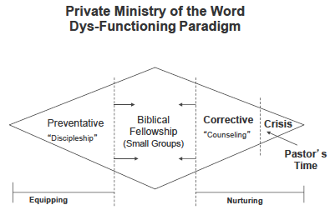

And not here..
If biblical counseling
Is happening only out here…
If biblical counseling
Is happening only out here…

e.g. special training
e.g. pastoral counseling

- Biblical Counseling happens in all healthy Christian communities.

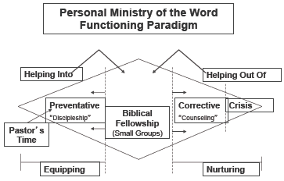

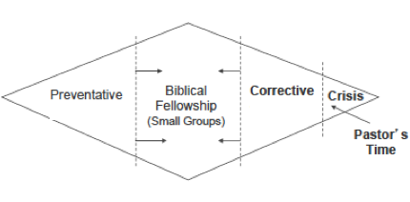
Eph.4:15-16
Speaking the truth in love…
We grow up into him
e.g. marriage counseling
e.g. BC Workshop
But if biblical counseling
Is happening here…

